EAGLE SKI CLUB TOUR
SUNNMØRE 2024
PROPOSED ITINERARY

The Sunnmøre Alps are noted for their dramatic mountains and excellent snow which lies well into Spring. This trip will be day tours in the region with ascents of typically 1000 – 1200m a day which will equate to approximately 6 – 7 hours out on the mountains.
We shall be based at a very comfortable AirBnB in the small town of Saebo, which has already been reserved (https://www.airbnb.co.uk/rooms/45272762?check_in=2023-10-17&check_out=2023-10-22&source_impression_id=p3_1692440138_r1RqQvG0J1Jd1FMA&previous_page_section_name=1000&federated_search_id=10c0258d-40c0-4d25-8f78-fb897b634013) nb the dates in this link are for illustration only!

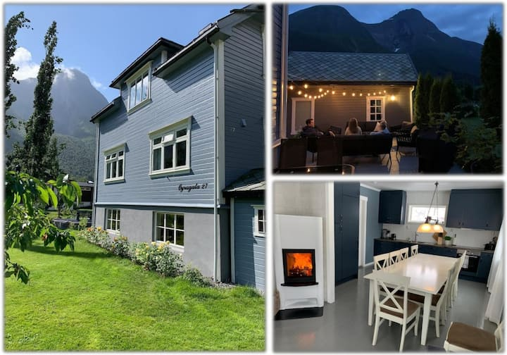

Dates: Saturday 6th April – Saturday 13th April 2024
Travel: Flight to either Oslo or Alesund and then possibly hire car or train to Andalsnes and hire car
Maps: Available through Kartverket online or map shops

Standard: E2/3, S3, M2

There may be some tricky mountain sections on this tour. Everyone should be familiar with crampons, ice-axe and harschiesen.

Costs: around £200/pp for the apartment and food costs shared – allow about £100 for that and extras such as fuel, etc.

Equipment: usual touring gear including skis, skins, harschiesen, transceiver, shovel, ice axe and crampons. Harnesses are not essential for most of the tours.

Insurance: a suitable travel insurance including helicopter rescue is compulsory.

I will provide a gear list and nearer the time we can arrange what group equipment we need.

Further details and Applications: Please apply on the standard ESC application form (from website) with a deposit for £120 to cover the property deposit either by BACS transfer to:

A M EDGERTON & P M EDGERTON
Sort code: 40-47-87
A/c No: 01816845

Or send a deposit cheque to the address below.

E-mail: rowanho@dircon.co.uk

Address: Rowan House, Highgate rd., Hayfield SK22 2JL
Phone: 01663-742367

