EAGLE SKI CLUB TOUR
NARVIK 2026
PROPOSED ITINERARY

The Narvik region offers a superb variety of ascents and two very comfortable DNT huts which the tour plans to use for 3 nights each. Surrounding these are mountains with ascents between 750-1200m and in one or two cases requiring travel over glaciers. As such, suitable equipment will be needed.
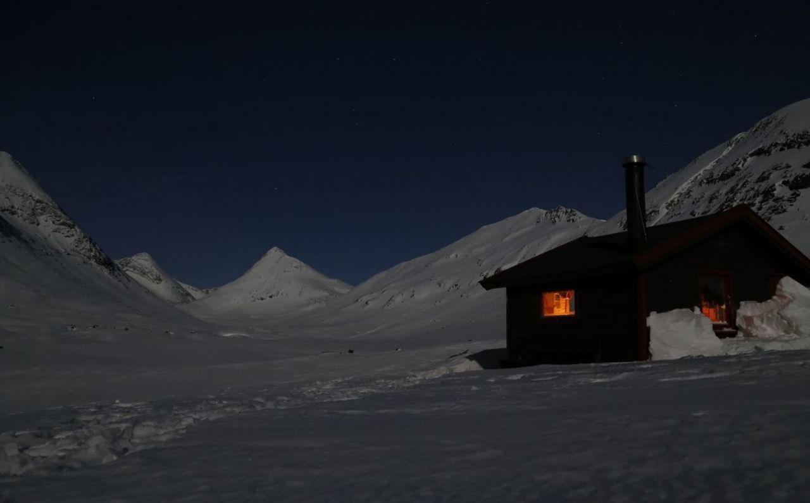
Dates: Friday 17th April – Friday 24th April 2026
Travel: As this is the week before the Tromsø tour which I will be joining, we will be flying there and hiring cars for the group to drive to Narvik, returning to Tromsø at the end of the week. NOTE: this tour goes Friday-Friday but I shall be travelling out to Tromsø on Thursday 16th. We shall drive to Narvik on Saturday 18th and return on Friday 24th.

General plan: Saturday – drive to Narvik, stock up and head up to Lossistua hut
Sunday & Monday – full days at the hut for ascents on nearby hills
Tuesday – ski out and transfer to Hundalen hut from the north, via Narvik
Wednesday & Thursday – full days at the hut for ascents
Friday – ski out and head back to Tromsø

Standard: E3, S3, M2
Maps: Through Norgeskart.no online or map shops such as Stanfords, The Map Shop, etc

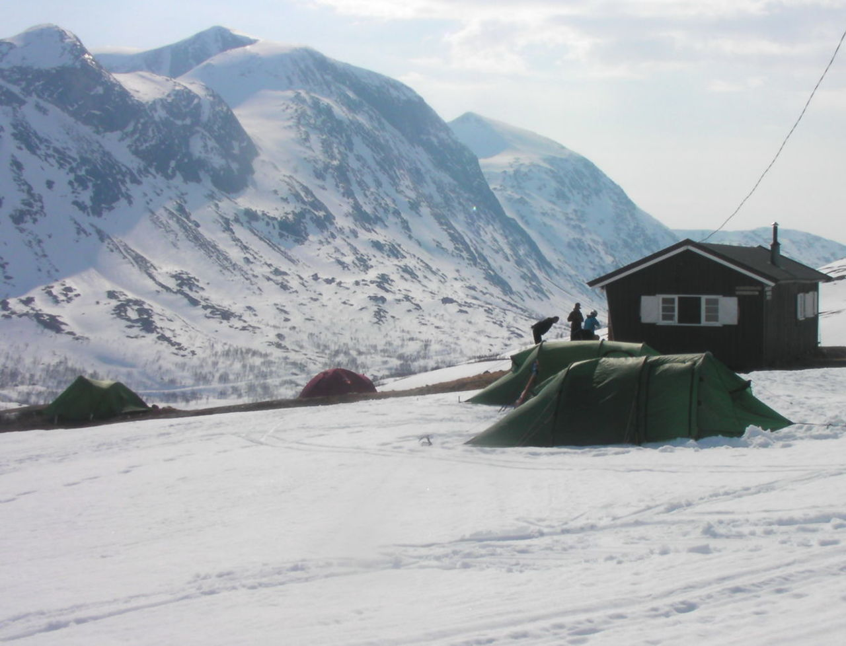
There may be some tricky mountain sections on this tour. Everyone should be familiar with crampons, ice-axe, harschiesen and glacier travel.

Costs: Approx. £200 for accommodation – allow about £200 for food and extras such as fuel, etc.

Equipment: usual touring gear including skis, skins, harschiesen, transceiver, shovel, ice axe and crampons. Harnesses may well be essential for any tour crossing the glaciers.
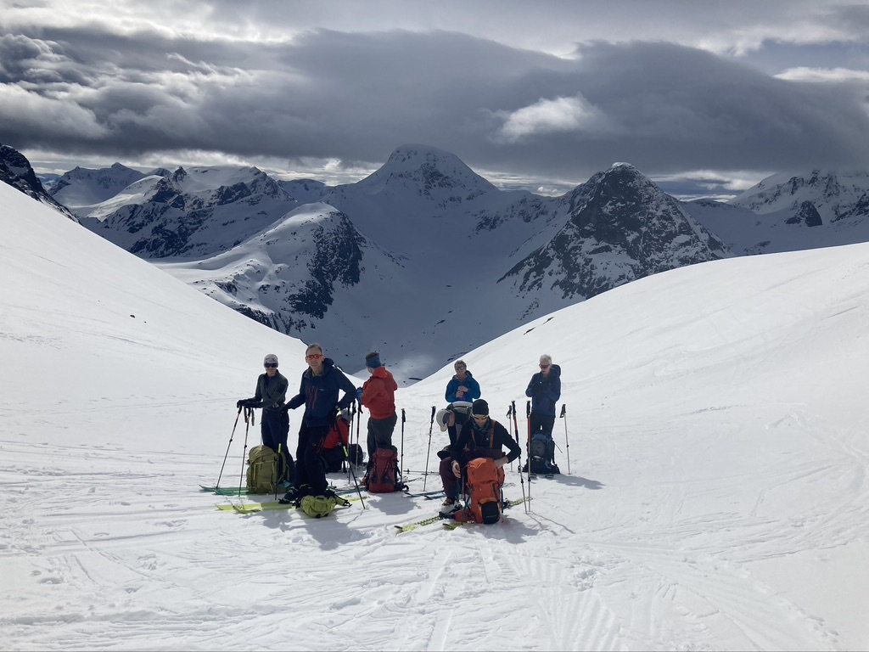
Insurance: a suitable travel insurance including helicopter rescue is compulsory.

I will provide a gear list and nearer the time we can arrange what group equipment we need. I will hold a Teams meeting sometime in the autumn once we have a group but will not consider applications until end September to allow anyone who wishes to apply.

Further details and Applications: Please apply on the standard ESC application form (from website) and if accepted, a deposit for £120 will be payable by BACS transfer to:

A M EDGERTON & P M EDGERTON
Sort code: 40-47-87
A/c No: 01816845

My details: E-mail: rowanho@dircon.co.uk

Phone: 01663-742367 / 07884-252227

