Avalanche Survival Curve

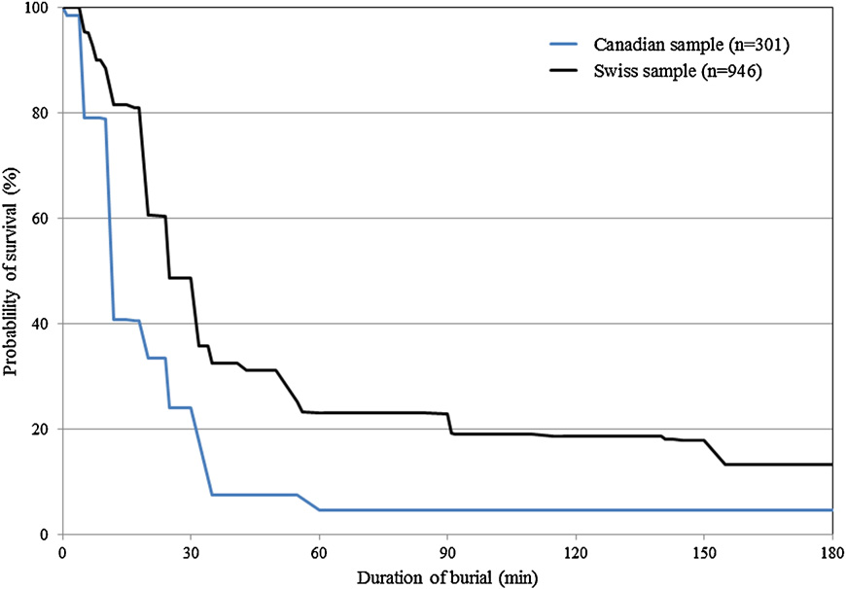
Asphyxia phase – survival drops quickly to approx. 20% at 60 minutes, as victims without an air pocket die.
Triple H phase - progressive death of victims with a “closed” air pocket from slow hypoxia/hypercarbia and hypothermia - only 7% survival at 130 min
Latent Phase – survival of those with an air pocket is maintained until approx 90minutes.
Organized rescue teams – have about 90 minutes to save the victim with the closed air pocket

Survival Phase – 80% survival at 18 minutes; deaths before this mainly due to severe trauma.
Companion rescue and resuscitation within 15 minutes offers the greatest chance of survival.

Fig 1 – Comparison of survival curves in Canada (Blue; n= 301) and Switzerland (Black; n=946) from 1980 to 2005. Extracted from Haegli P., et al (2011).

